About Me

Basic Info

Sex:

Birthday:

Parents:

Siblings:

Children:

Relationship Status: Married to

Current City:

Bio

QUOTE

Friends

Number of Friends

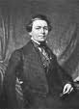

Friend 1

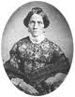

Friend 2

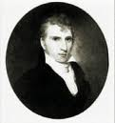

Friend 3



Friend 4



Friend 5

Likes and Interests

Activities

Athletics: 

Gambling 

Drinking 

Education and Work

Employers

Grad School

College

High School

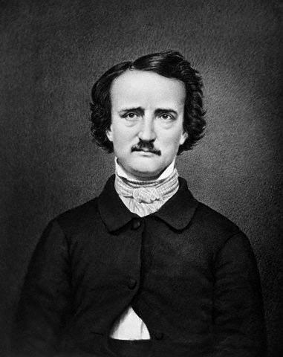

WALL INFO PHOTOS BOXES VIDEO NOTES >> +

Name

**Farcebook**  home profile account